**Dummy Form Request and Response Structure**

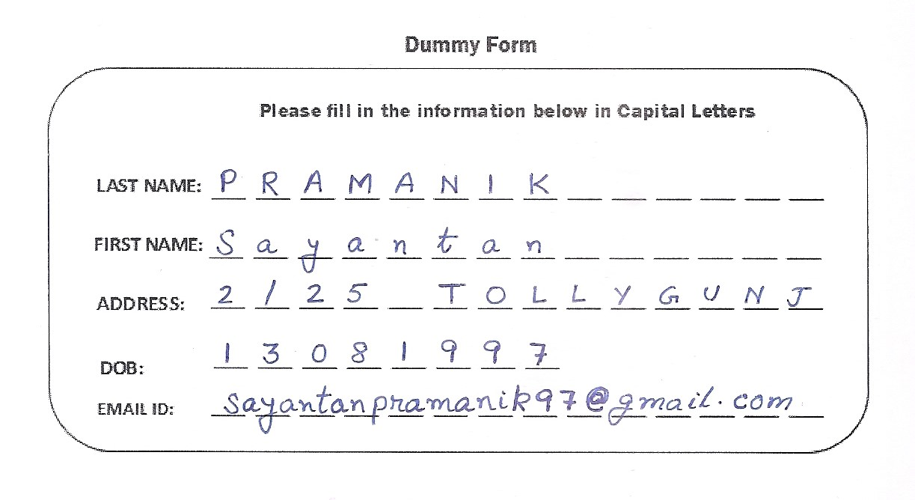

Request Structure:

{

“imageFormat”: “png”,

“formType”: “dummyForm”, // “dummyForm” will be replaced by the name of the form

“images”: [ “//base64 of image 1” ] /*presently supports only 1 image whose

template is available*/

}

Response:

{

"dummyLines": [

{

"confidence": "low",

"key": "LAST NAME",

"value": "I RAMANI K"

},

{

"confidence": "high",

"key": "FIRST NAME",

"value": "S a y"

},

{

"confidence": "low",

"key": "ADDRESS",

"value": "2 !Jan tan 2 1I O LLY GUNJ"

},

{

"confidence": "low",

"key": "DOB",

"value": "1 3 0 8 1 9 9 7"

},

{

"confidence": "low",

"key": "EMAIL ID",

"value": "Sayan tan pra manik 9 7 @ g mail com"

}

],

"dummyStatus": "Succeeded"

}

Class Structure:

**public** **class** dummyImageResponse

{

ArrayList<fieldsJson> dummyLines = **new** ArrayList<fieldsJson>();

String dummyStatus;

}

**public** **class** fieldsJson

{

String key;

String value;

String confidence;

}